Quiz 2

Nicholas Colonna

1/24/2018

## Assume you have a geometric distribution X ~ Ge(0.3)

#1 Generate 1000 random numbers from geometric distribution with p = 0.3  
x <- rgeom(1000, 0.3)  
  
#2 Make a histogram for the random numbers  
hist(x, ylim=c(0,1), freq=F)

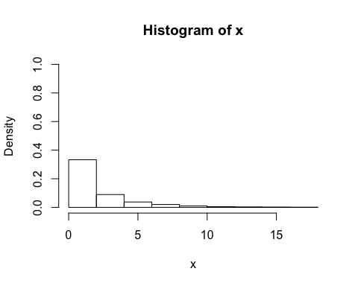

#3 Make a density plot based on the true distribution  
plot(x=seq(0,max(x)), y = dgeom(seq(0,max(x)), 0.3), type = "l" )

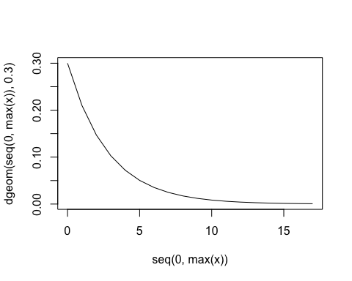

#4 Make a CDF plot based on the true distribution  
y <- seq(-1,(max(x)+1), by=0.01)  
plot(y, pgeom(y,0.3))

